Lab 10: Simulate Multiplication Operation

Learning Objectives:

* Use basic assembly instructions for the multiplication operation.
* Store the inputs in memory before performing the operation.
* Execute Branch Instructions

Essential Tools in Our Lab:

* **Computer System:** The main machine
* **CPU Sim**: CPU Sim is a tool used for simulating simple CPU architectures, helping students understand processor design, instruction execution, and debugging.

**Program**

|  |  |
| --- | --- |
| START: |  |
| INP | ; Take first input from the user and store it in the accumulator |
| STA NUM | ; Store the value from the accumulator into memory location NUM |
| INP | ; Take second input from the user and store it in the accumulator |
| MULTIPLY NUM | ; Perform multiplication between AC and the stored NUM value |
| OUT | ; Output the result of the AND operation |
| HLT | ; Halt execution |
|  |  |
| NUM: .data 1 0 | ; Memory location to store the first input, initially set to 0 |

Basic Machine Instructions

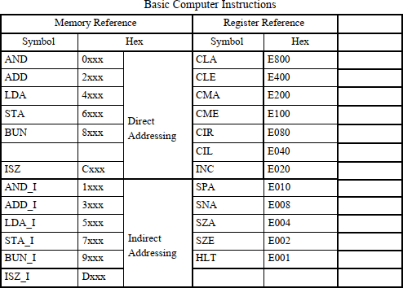

Step 1: Navigate to the Microinstructions Section

* **Open your simulator/tool and access the Microinstructions Section.**

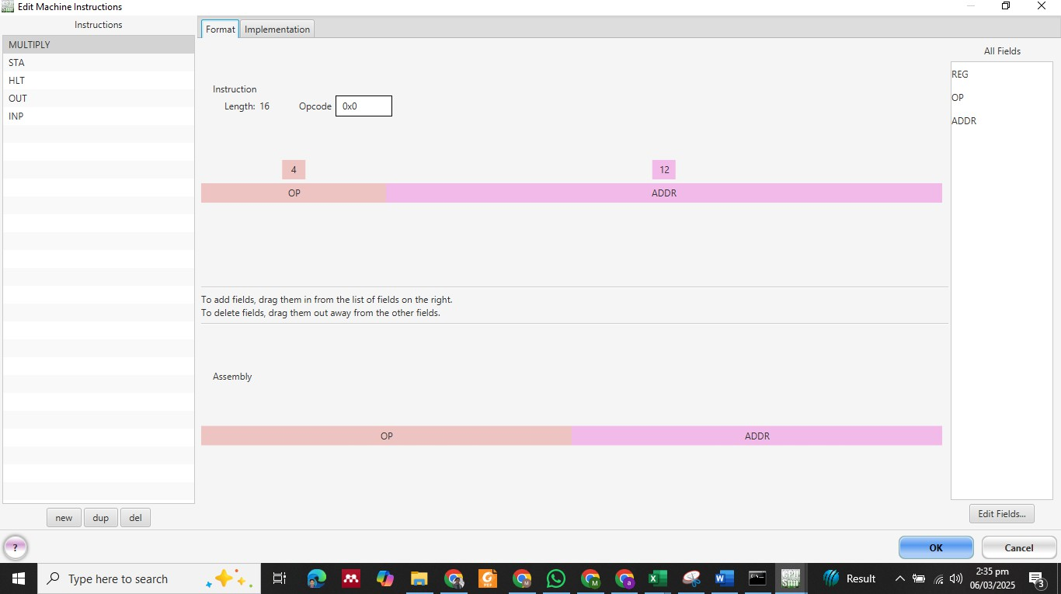

Step 2: Define Multiply Microinstruction

* **This instruction performs multiplication operation between the Accumulator (AC) and a memory location (M).**
* **Set the Opcode for MULTIPLY as 0.**
* **Set it as a Opp & Address. Step 2:**
* **Go to Implementation and select Arithmetic Instruction with the operation AC<-AC*DR**

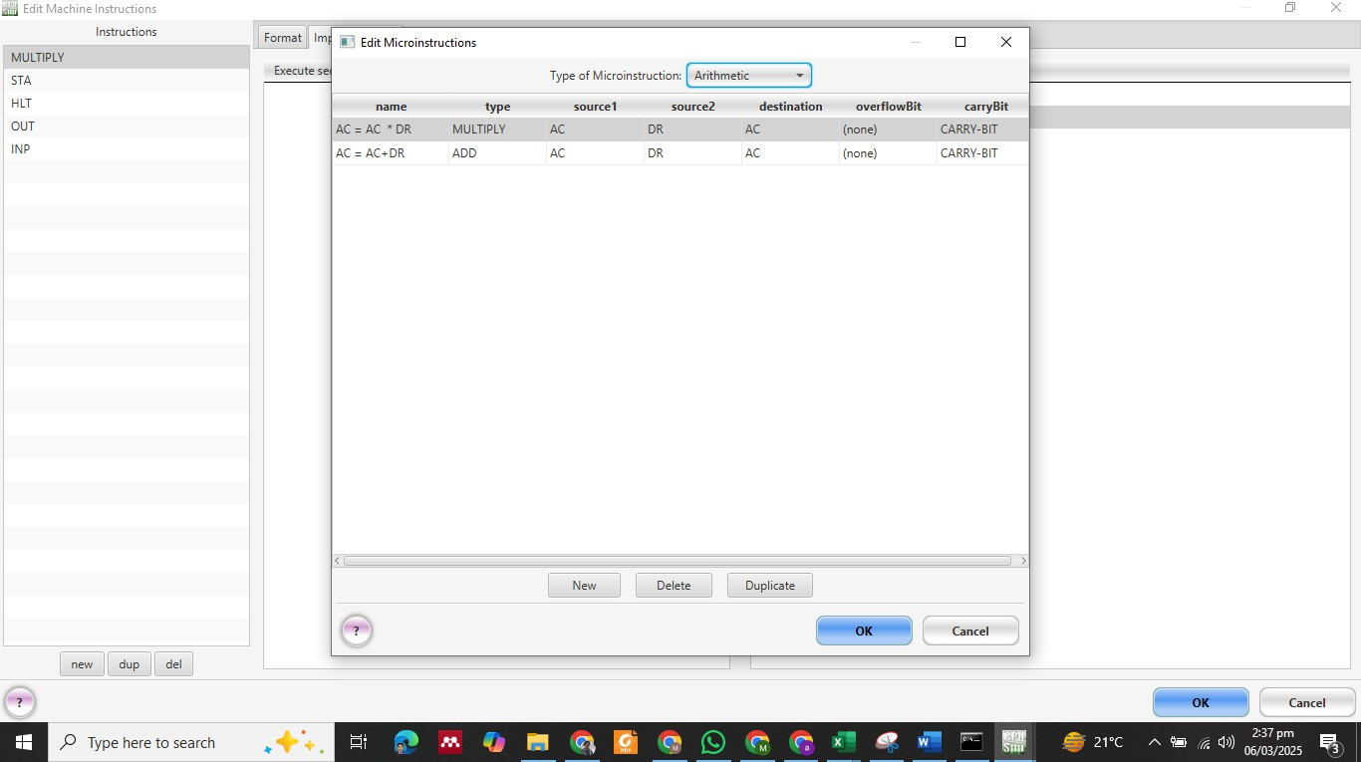

* 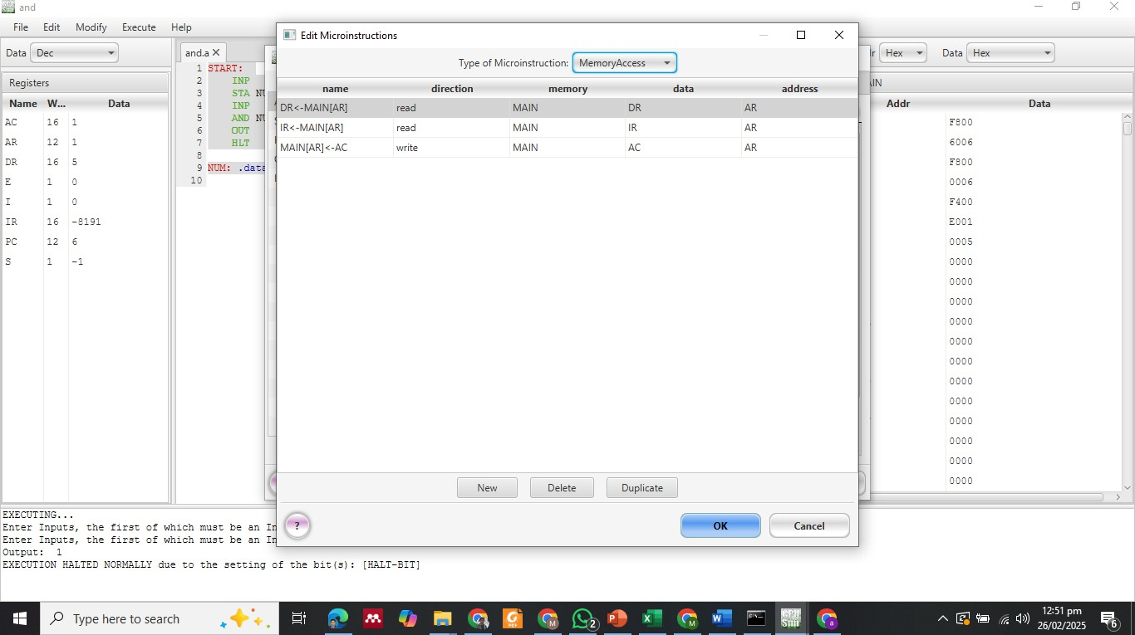**Accumulator (AC) and a memory location (M)**
* **Define a Sequence Instruction for execution.**

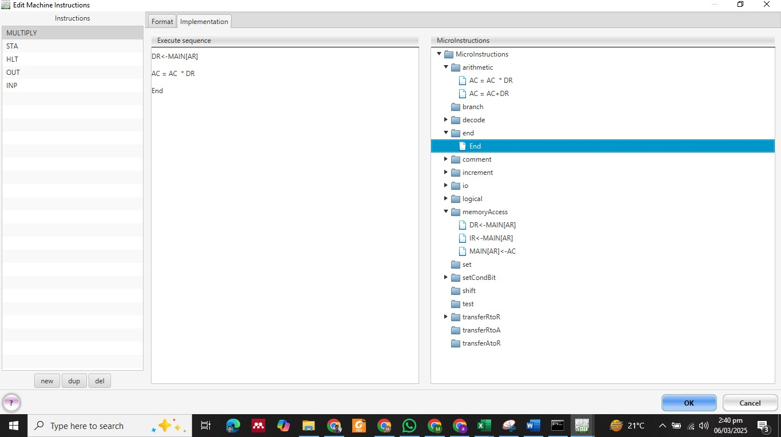

Results :

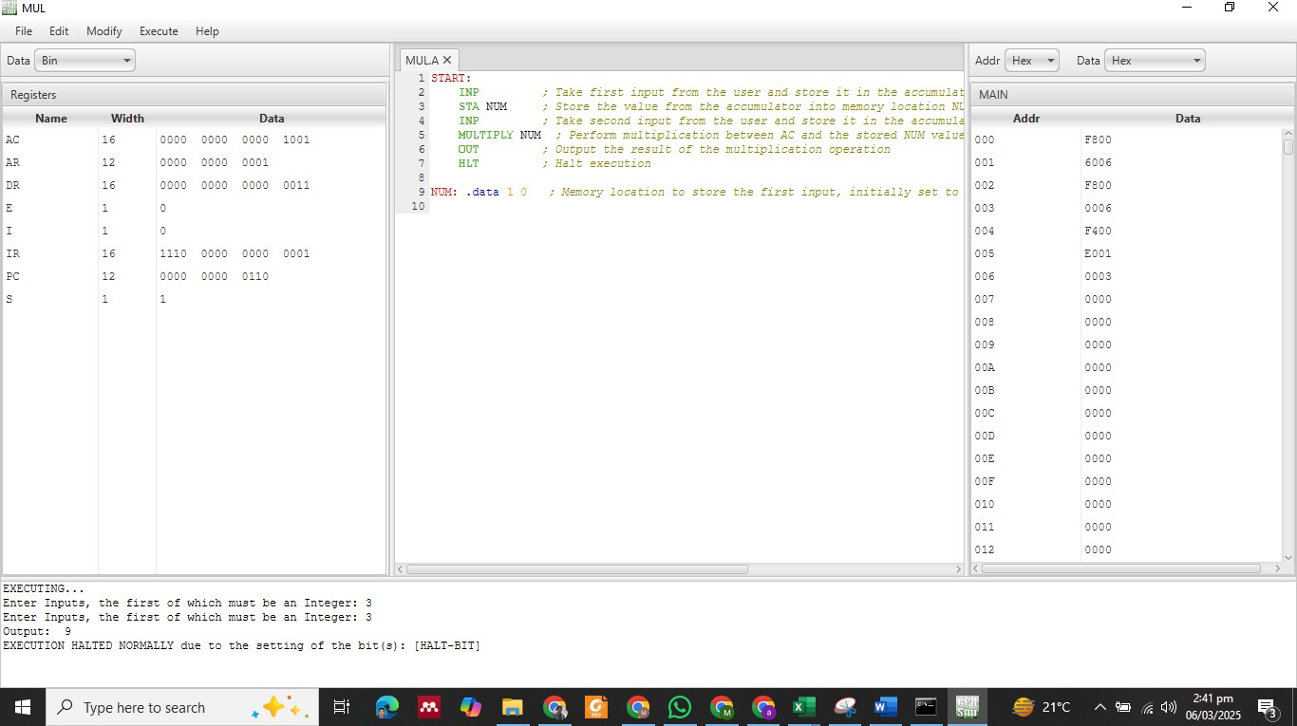

Lab Tasks

Task # 1:

1. **Take an input from the user and store it in memory.**
2. **Retrieve the stored value from memory using the LDA instruction.**
3. **Display the loaded value as output. Instructions:**
   * **Verify that the value remains the same after storage and retrieval.**
   * **Analyze the execution and document the results.**